**Lane Detection with OpenCV**

**Overview :** For completion of this lane detection assignment we use OpenCV. To understand the core fundamentals of detection a image, firstly an foundation approach was selected which uses canny detection and hough transform algorithm with some pre-processing to detect lanes as illustrated in approach.

**Approach:**

In this approach opencv is used predominantly to detect lanes in an image. An input pipeline consists of techniques applied on the image in a sequences as illustrated in below.

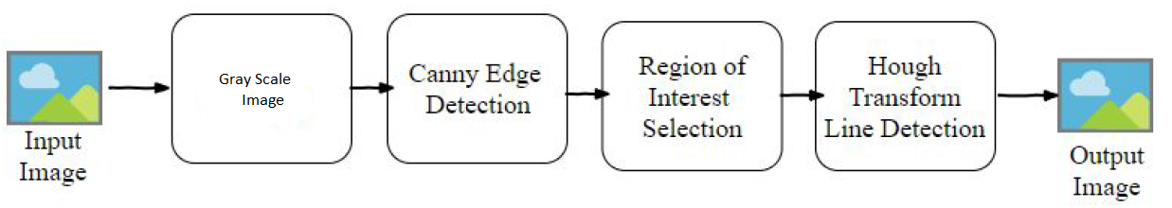

**Gray Scale Image :** The images are loaded in RGB color space. The intention of this technique is to convert the RGB(3-channel) to Gray-scale image(1-channel) . Using ***cv2.cvtColor*** , we can convert RGB image into gray-scale. And with the help of Gussian Blur the noise of image has be removed.

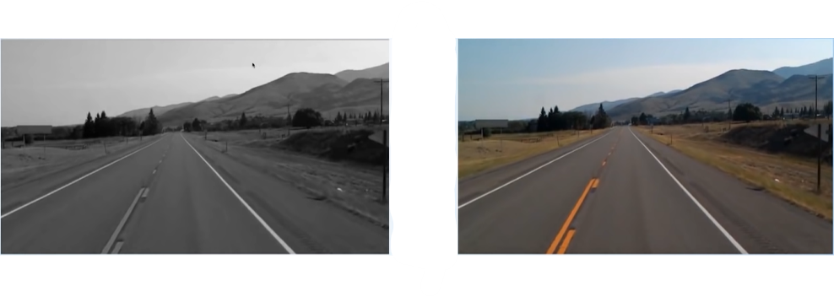

**Canny Edge Detector :** The main objective of this technique is to to detect edges in order to find straight lines especially lane lines. For this we have to convert images to grayscale, smooth out rough lines, find the edges So firstly converting the white and yellow line images from the above process into gray scale for edge detection. Than we should make the edges smoother, as the above images may have many rough edges which causes many noisy edges to be detected. And lastly use canny edge detection to detect the edges.

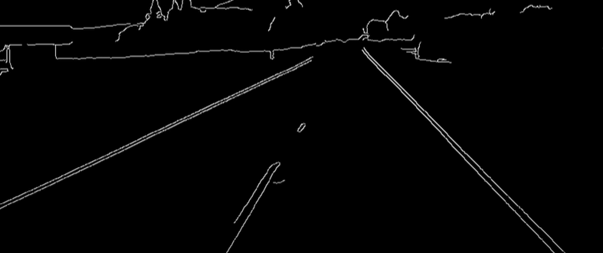

**Region of Interest selection :** When finding lane lines, we don’t need to check the cloud and the mountains in a image. Thus the objective of this technique is to concentrate on the region of interest for us that is the road and lane on the road.

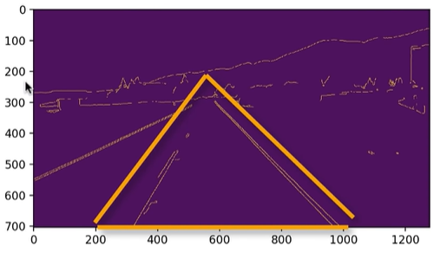

**Hough Transform Line Detection :** The objective of the Hough Line Transform algorithm is to detect lines in the edge image outputted from the above process. Moreover there are multiple lines detected for a lane line. Thus we should come up with an averaged line for that. Also, some lane lines are only partially recognized. Thus extrapolation of the line to cover full lane line length is required.

